

|  |  |  |  |  |  |  |  |  |
| --- | --- | --- | --- | --- | --- | --- | --- | --- |
|  | | | | | | | | |
|  | | AI PROJECT | | | | |  | |
|  |  | | | | | | |  |
|  | | | |  |  | | | |
|  | | | | Harpreet Kaur |  | | | |
|  | | | | June 17,2025—Artificial Intelligence—Professor Mostafa Omar 😊 |  | | | |
|  | | |  | | |  | | |

|  |  |  |  |  |  |  |  |  |
| --- | --- | --- | --- | --- | --- | --- | --- | --- |
|  |  | | |  |  | | |  |
|  | INTRODUCTION | | | | | | |  |
|  |  | | |  |  | | |  |
|  |  | |  | | |  | |  |
|  |  |  | **Artificial Intelligence (AI)** is a branch of computer science focused on creating machines that can perform tasks typically requiring human intelligence. These tasks include learning from data, recognizing patterns, understanding language, and making decisions. AI is used in many everyday applications, such as voice assistants, recommendation systems, and self-driving cars. As technology advances, AI continues to play a growing role in improving efficiency, solving complex problems, and transforming various industries. | | |  |  |  |
|  | | | | |
|  |  |  |  |
|  |  |



The 8-puzzle problem is a classic combinatorial search challenge that involves rearranging a 3×3 grid of numbered tiles to reach a predefined goal configuration. This project explores and compares a range of search algorithms—both uninformed (Breadth-First Search, Depth-First Search, Depth-Limited Search, Iterative Deepening Search, and Uniform Cost Search) and informed (Greedy Best-First Search and A* Search)—to solve the 8-puzzle effectively. Each algorithm is implemented in Python and evaluated based on solution optimality, completeness, memory efficiency, and execution time. The experimental results demonstrate that while uninformed methods like BFS and UCS can yield optimal paths, they suffer from high memory demands. In contrast, informed techniques such as A* and Greedy Best-First Search leverage heuristics like Manhattan Distance to prioritize promising paths, significantly reducing the number of node expansions. Among all, A* Search consistently provided the best trade-off between performance and accuracy, solving the puzzle in the shortest path length with optimal computational efficiency. These findings highlight the importance of heuristic guidance in real-world AI planning and pathfinding problems.

# ABSTRACT



|  |  |  |  |  |  |  |  |  |
| --- | --- | --- | --- | --- | --- | --- | --- | --- |
| Decorative | |  |  | | |  |  | |
|  | | THE PROCESS | | | | |  | |
|  | |  |  | | |  |  | |
|  | PROBLEM STATEMENT The 8-puzzle is a sliding puzzle consisting of a 3x3 grid with tiles numbered 1 through 8 and a blank space. The goal is to reach a target configuration by sliding tiles into the blank space. This problem models real-world challenges in robotics and AI.  Solution steps can be ignored or undone ... | | | | | | |  |
|  | Approach Overview | | |  |  | | |  |

* A search problem consists of:
  + **A State Space.**Set of all possible states where you can be.
  + **A Start State.**The state from where the search begins.
  + **A Goal State.**A function that looks at the current state returns whether or not it is the goal state.
* The **Solution**to a search problem is a sequence of actions, called the **plan**that transforms the start state to the goal state.
* This plan is achieved through search algorithms.

|  |  |  |  |
| --- | --- | --- | --- |
|  |  |  |  |

|  |  |  |  |
| --- | --- | --- | --- |
|  | Search Algorithms in Artificial Intelligence:  In Artificial Intelligence, **search algorithms** are categorized into two main types:   * Uninformed Search * Informed Search |  | |
|  |  | |  |
|  |  |  | |

|  |  |  |  |
| --- | --- | --- | --- |
|  |  |  |  |



UNINFORMED SEARCH

Uninformed search (also called blind search) refers to search strategies that have **no additional information** about states beyond that provided in the problem definition. These algorithms can only generate successors and differentiate between the goal state and non-goal state.

In this project, we implemented and analysed the following two uninformed search algorithms:

1. Breadth First Search
2. Depth First Search
3. Depth-limit Search
4. Iterative deepening Search
5. Uniform Cost Search

|  |
| --- |
|  |

Each of these algorithms will have:

* A problem **graph,**containing the start node S and the goal node G.
* A **strategy,**describing the manner in which the graph will be traversed to get to G.
* A **fringe,**which is a data structure used to store all the possible states (nodes) that you can go from the current states.
* A **tree,**that results while traversing to the goal node.
* A solution **plan,**which the sequence of nodes from S to G.

##### 1.Breadth First Search

BFS is an uninformed search algorithm that explores all possible states level by level, starting from the initial state. It checks all possible moves at each level before moving on to the next. BFS **guarantees** that the solution found is the shortest in terms of the number of moves, but it can be very slow and memory-intensive for large search spaces like the 8 Puzzle.

**Step by step approach:**

* Start from the root node.
* Explore all neighbouring nodes at the present depth.
* Move to the next depth level and repeat the process.
* If a goal state is reached, return the solution.

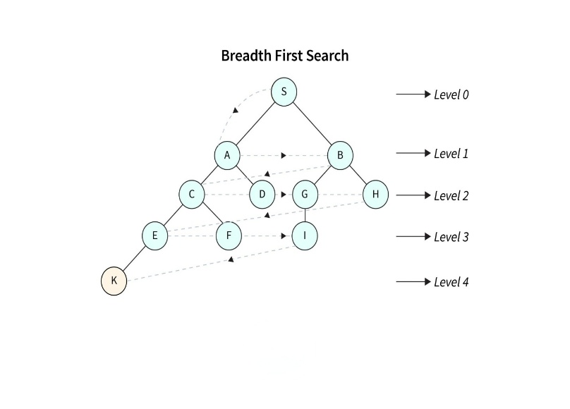

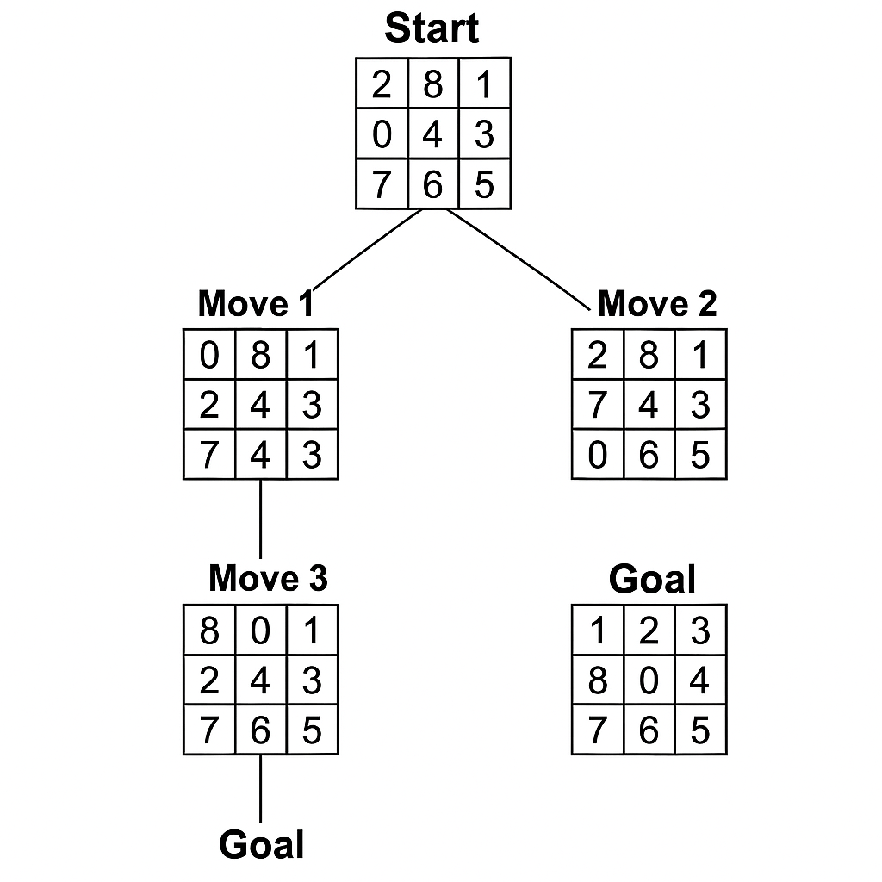

|  |  |  |  |
| --- | --- | --- | --- |
|  | Time & Space Complexity: O(b^d) Where b ≈ 2.1 (branching factor) and d = 9 (solution depth). Both grow exponentially with depth.   * The branching factor is the number of valid child states generated from a given puzzle configuration. * In the 8-puzzle, the blank tile (0) moves to generate new states. * Possible directions: up, down, left, right (depending on position). * Positions: * Corner tiles → 2 moves * Edge tiles → 3 moves * Center tile → 4 moves * In this example, the blank starts at position (1,0) → middle-left → 3 valid moves * ✅ Therefore, the branching factor at the start node is 3 * 📊 Average branching factor across all states in the 8-puzzle is approximately 2.13   Applications of BFS in Graphs  BFS has various applications in graph theory and computer science, including:  **Adv Applications of BFS in Graphs**   * **Shortest Path Finding:** Finds the shortest path in unweighted graphs by tracking parent nodes. * **Cycle Detection:** Identifies cycles if a node is revisited during traversal. * **Connected Components:** Detects groups of nodes that are mutually reachable. * **Topological Sorting:** Orders nodes in a DAG such that each node appears before its dependents. * **Level Order Traversal:** Traverses binary trees level by level. * **Network Routing**: Finds shortest paths for data transmission in networks.   **Advantage:**  Guaranteed to find the optimal solution (shortest number of moves).  **Disadvantage:**  BFS has a high memory requirement, as it must store all the states at each level of exploration.  **Figure 1: BFS solving the 8-puzzle in 9 moves, showing each step and final configuration.** |  |  |

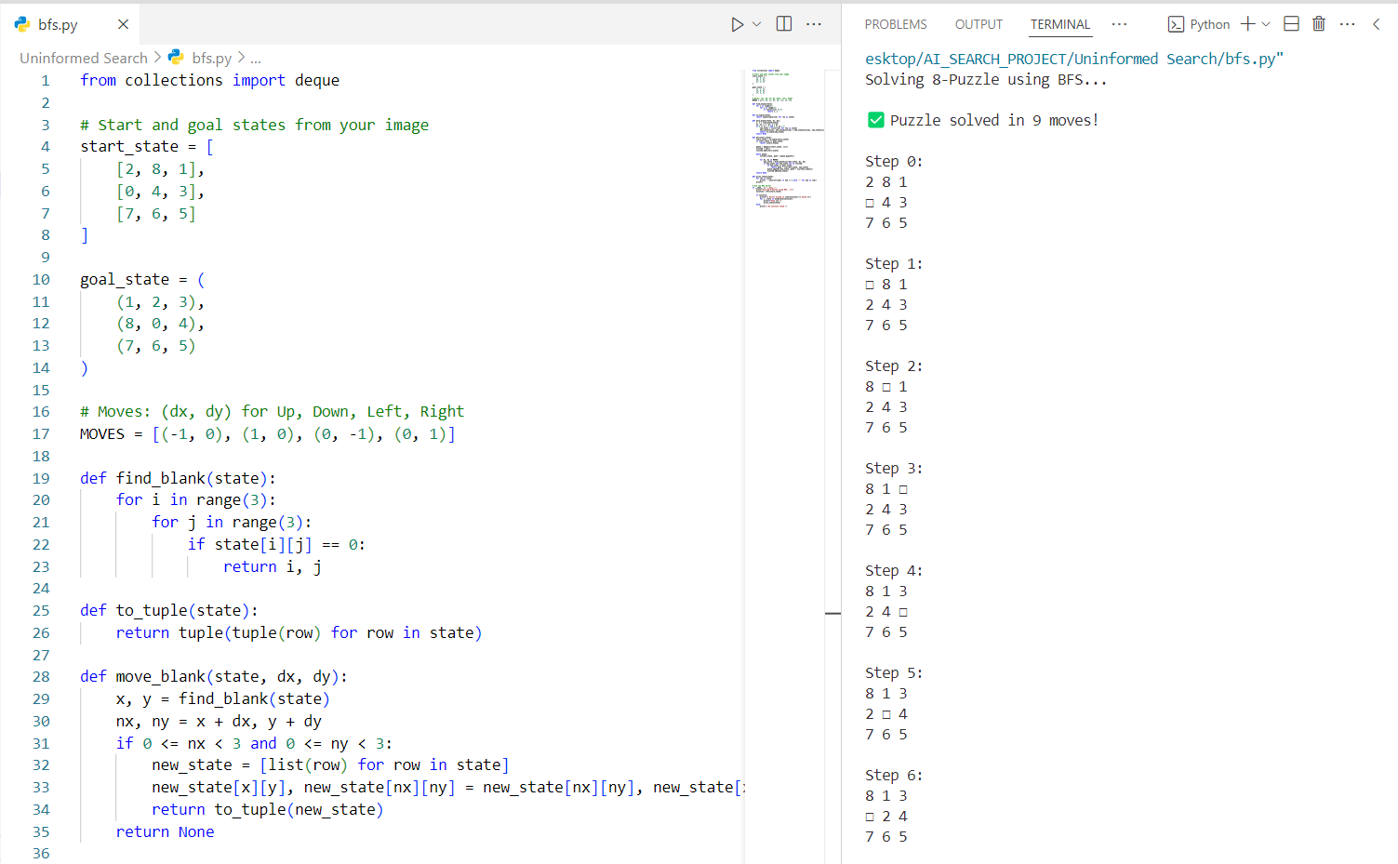

:

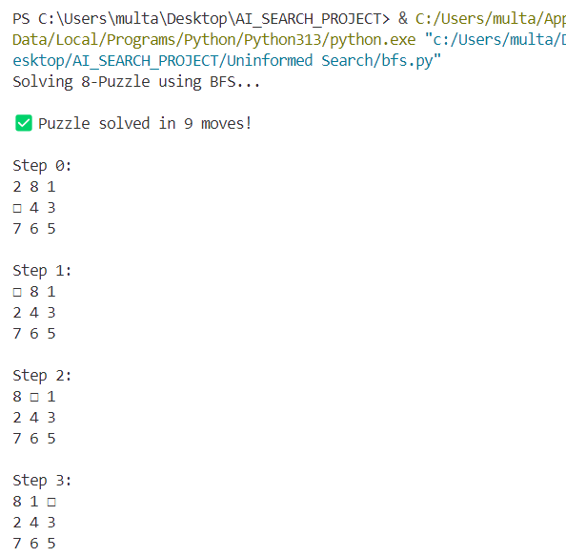

**As shown in Figure 1, BFS solved the 8-puzzle in 9 moves, demonstrating its completeness and optimality.**

##### 2.Depth First Search

Depth-First-Search is a traversing algorithm used intree and graph-like data structures. It generally starts by exploring the deepest node in the frontier. Starting at the root node, the algorithm proceeds to search to the deepest level of the search tree until nodes with no successors are reached. Suppose the node with unexpanded successors is encountered then the search backtracks to the next deepest node to explore alternative paths.

**Step by step approach:**

* Start from the root node.
* Explore the leftmost child node recursively until you reach a leaf node or a goal state.
* If a goal state is reached, return the solution.
* If a leaf node is reached without finding a solution, backtrack to explore other branches

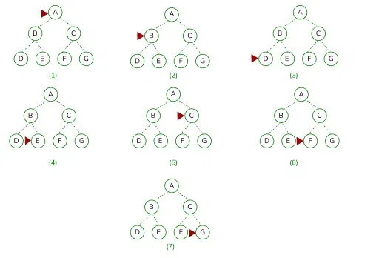

**Complexity**  
d = the depth of the search tree = the number of levels of the search tree.   
ni= number of nodes in level i.  
**Time complexity**: Equivalent to the number of nodes traversed in DFS. T(n)=1+n2+n3+...+nd=O(nd)   T(n)=1+n2+n3+...+nd=O(nd)        
**Space complexity:** Equivalent to how large the fringe can get. S(n)=O(n×d)  
**Completeness**: DFS is complete if the search tree is finite, meaning for a given finite search tree, DFS will come up with a solution if it exists.   
**Optimality**: DFS is not optimal, meaning the number of steps in reaching the solution, or the cost spent in reaching it is high.

**Figure 2: DFS explored 25,000+ states without finding solution**

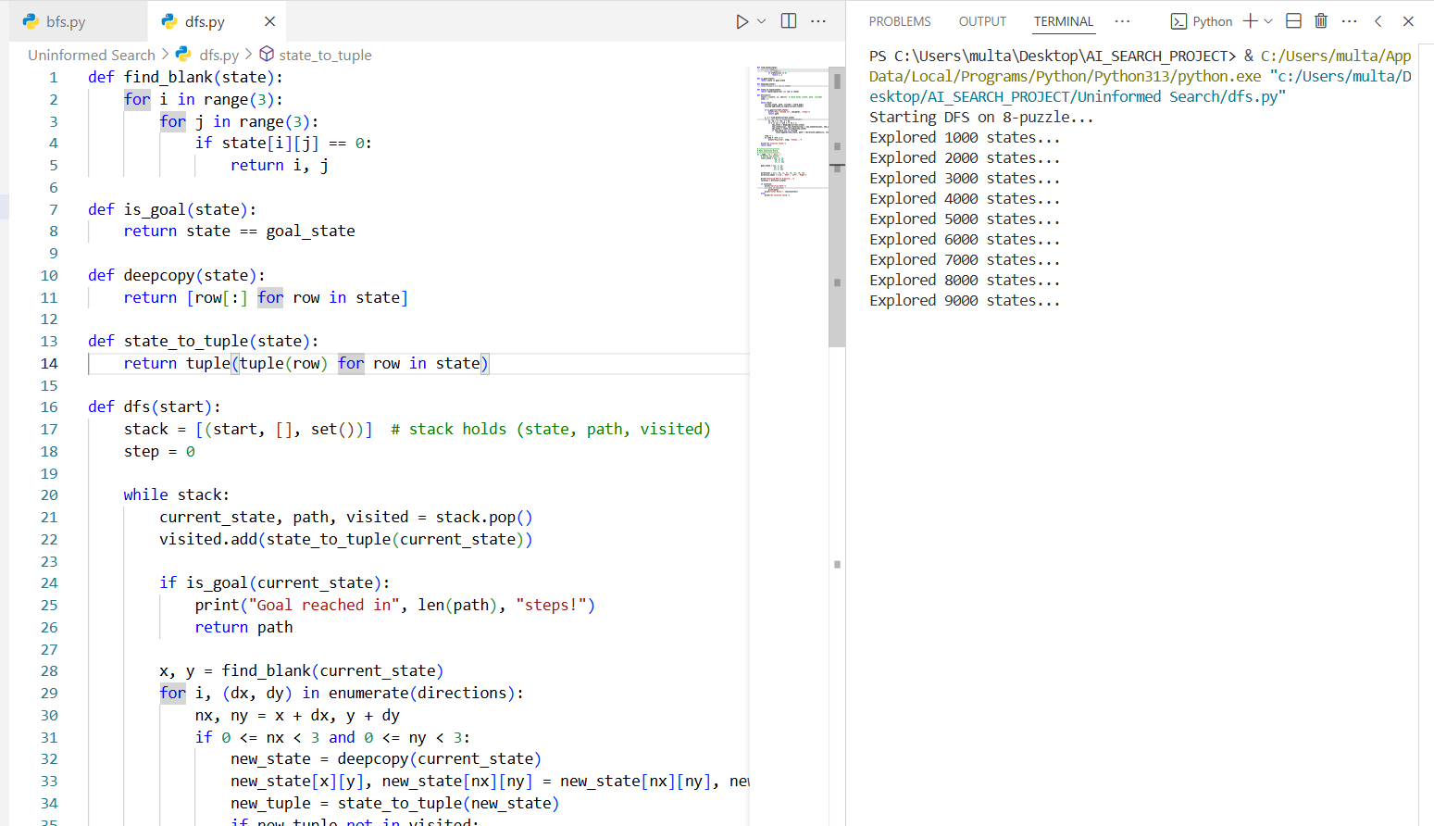

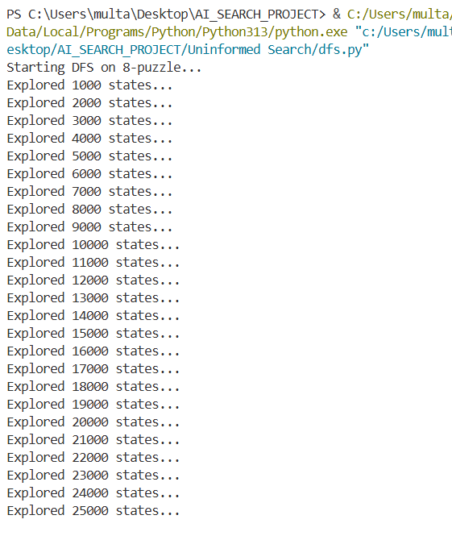

### **As shown in Figure 2, DFS explored over 25,000 states without reaching the goal, highlighting its tendency to get stuck in deep, unproductive branches and lack of optimality**

##### .3.Depth-limit Search

**Depth-Limited Search** is a variation of Depth-First Search (DFS) with a specified **maximum depth limit**. This avoids the problem of getting stuck in infinite paths (common in DFS) by preventing the algorithm from going deeper than a certain level in the search tree.

It is particularly useful when the solution is known to exist within a specific depth.

**Step-by-Step Approach**

1. **Initialization:** Begin with the root node and a predefined depth limit L.
2. **Explore Recursively:** Traverse each node’s children using DFS-style exploration.
3. **Depth Check:** If current depth exceeds L, stop recursion on that branch.
4. **Goal Test:** If a goal node is found before the limit, return it.
5. **Backtracking:** If the depth limit is reached without solution, backtrack and try other unexplored paths.

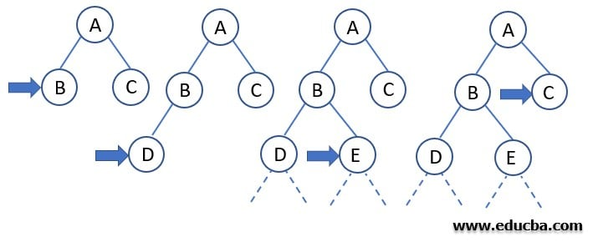

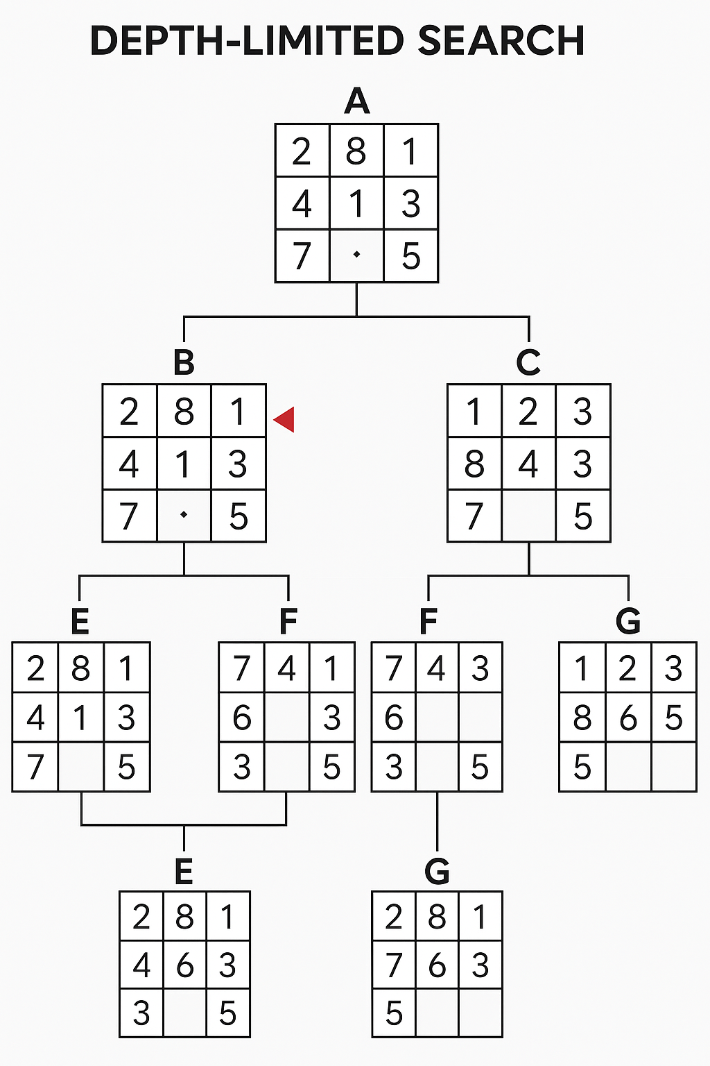

**Complexity**  
d = the depth of the search tree = the number of levels of the search tree.   
ni = number of nodes in level i.   
  
**Time complexity**: Equivalent to the number of nodes traversed in DFS. T(n)=1+n2+n3+...+nd=O(nd)    T(n)=1+n2+n3+...+nd=O(nd)          
**Space complexity:** Equivalent to how large the fringe can get. S(n)=O(n×d)  
**Completeness**: DFS is complete if the search tree is finite, meaning for a given finite search tree, DFS will come up with a solution if it exists.   
**Optimality**: DFS is not optimal, meaning the number of steps in reaching the solution, or the cost spent in reaching it is high.

**Applications of Depth Limited Search in AI**

1. **Pathfinding in Robotics:** DLS is employed for nonholonomic motion planning of robots in the presence of obstacles. By imposing restriction on the depth it makes the robot stop after exploring a particular depth of an area and restricting the robot from too much wandering.
2. **Network Routing Algorithms:** A DLS can be implemented to compute paths between nodes in computer networks restricting the number of hops to prevent loops.
3. **Puzzle Solving in AI Systems:** DLS can be used to solve puzzles such as the 8-puzzle or Sudoku by manipulating possible moves a fixed number of times that reduces how many steps are taken in the search.
4. **Game Playing:** In AI for games, instead, DLS can be used to plan forward a few moves up to a certain level of depth to help decide how much effort to put into a given decision.

**Advantages of Depth-Limited Search (DLS)**

* Prevents infinite loops by limiting the depth of the search.
* Requires less memory, similar to DFS (space complexity = O(depth)).
* Simple to implement — it’s just DFS with a depth cutoff.
* Allows controlled exploration when you have an estimate of the solution depth.

**Disadvantages of Depth-Limited Search (DLS)**

* Not complete if the solution lies beyond the depth limit.
* Not optimal — may return a longer path even if a shorter one exists.
* Requires manual setting of depth limit, which may be difficult to estimate.
* Can waste time exploring irrelevant deep paths up to the cutoff.

**Figure 3: DLS reached goal in 20 moves using depth limit**

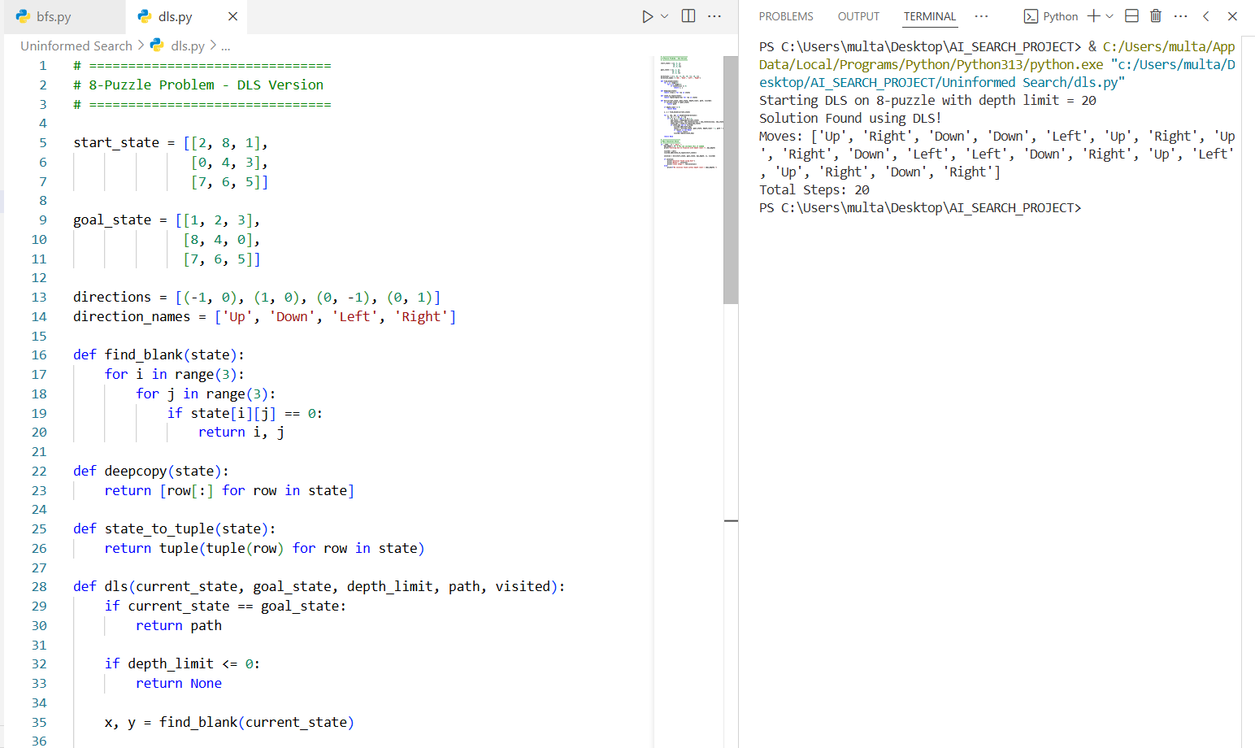

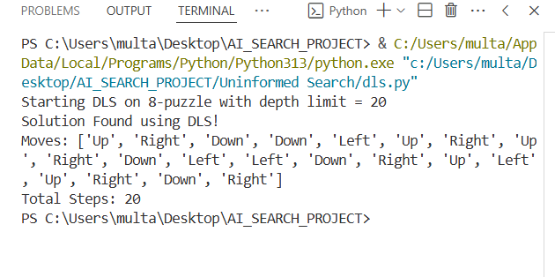

**As shown in Figure 3, DLS reached the goal state in 20 moves using a fixed depth limit of 20, which prevented infinite loops but failed to find an optimal solution.**

##### 4.Iterative Deepening Search

**Iterative Deepening Search (IDS)** is an uninformed search strategy that repeatedly applies **Depth-Limited Search (DLS)** with increasing depth limits until a solution is found. It merges the benefits of both **Breadth-First Search (BFS)** (completeness, optimality) and **Depth-First Search (DFS)** (low memory usage).

**Step-by-Step Approach**

1. Set initial depth limit L = 0.
2. Run Depth-Limited Search with limit L.
3. If the goal is not found, increment L and repeat.
4. Continue until a solution is found or a maximum depth is reached.

**Illustration:** There can be two cases:

1. ***When the graph has no cycle:*** This case is simple. We can DFS multiple times with different height limits.
2. ***When the graph has cycles.*** This is interesting as there is no visited flag in IDDFS.

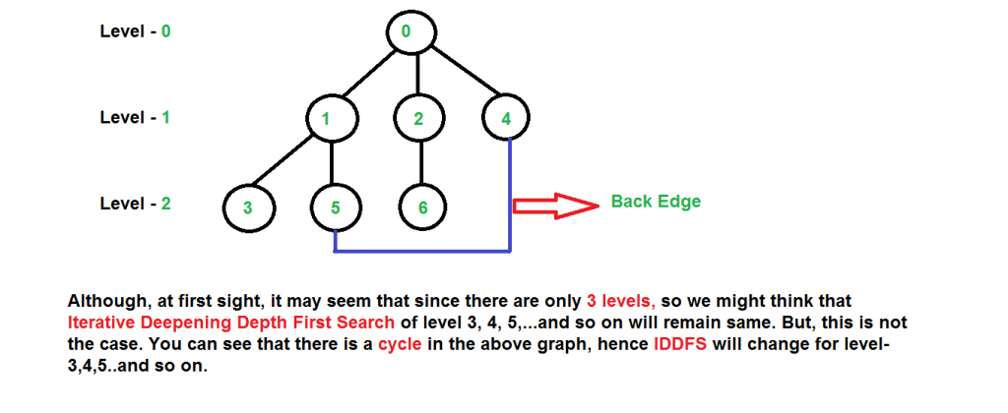

**Complexity**

| **Metric** | **Value** |
| --- | --- |
| Time Complexity | O(b^d) |
| Space Complexity | O(b × d) |
| Complete? | ✅ Yes |
| Optimal? | ✅ Yes (if step cost is uniform) |

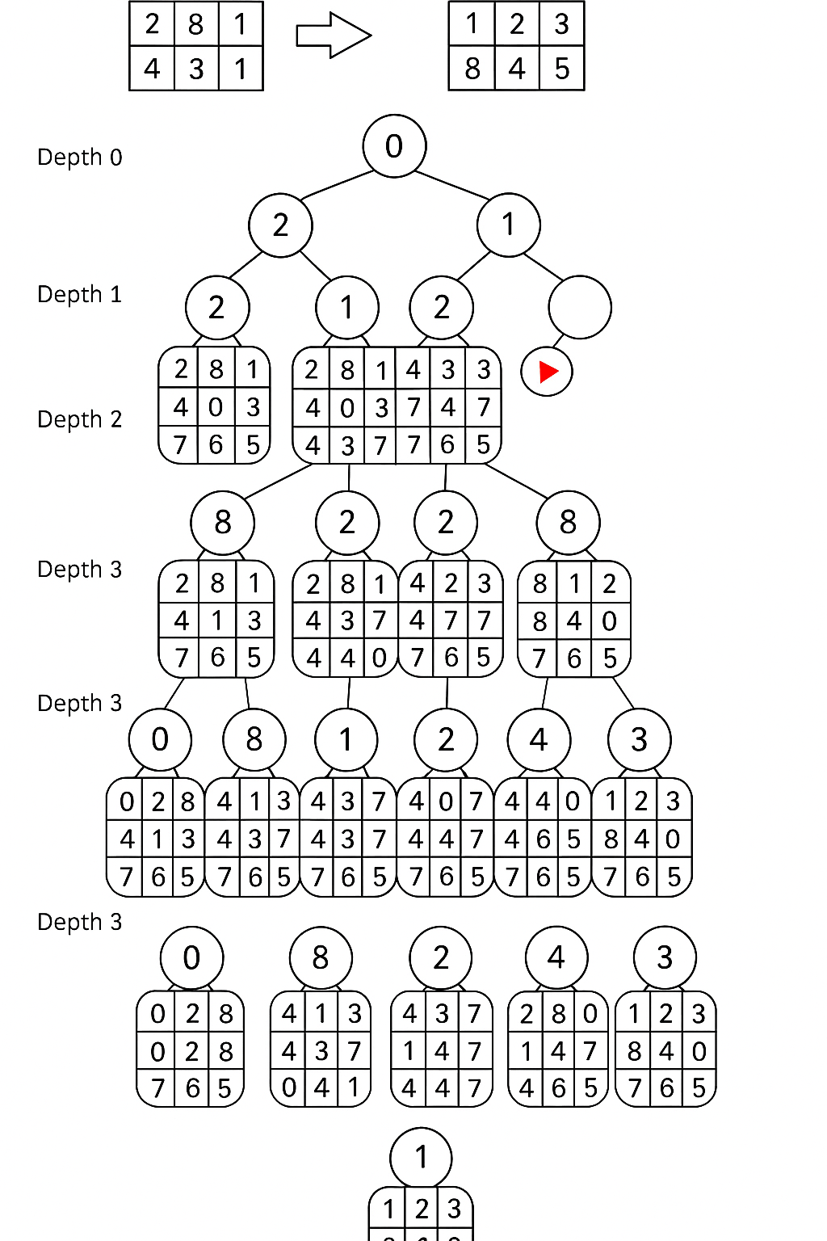

**Advantages of IDS**

* ✅ Complete — guaranteed to find a solution if one exists.
* ✅ Optimal — returns the shortest path (if step costs are equal).
* ✅ Memory efficient — uses DFS-style linear space.
* ✅ No infinite loop risk — avoids DFS’s drawback.

**❌ Disadvantages of IDS**

* ❌ Repeats work — nodes near the top of the tree are expanded multiple times.
* ❌ Can be slower than BFS in shallow solutions due to redundant explorations.

##### Figure 4: IDS found goal at depth 10

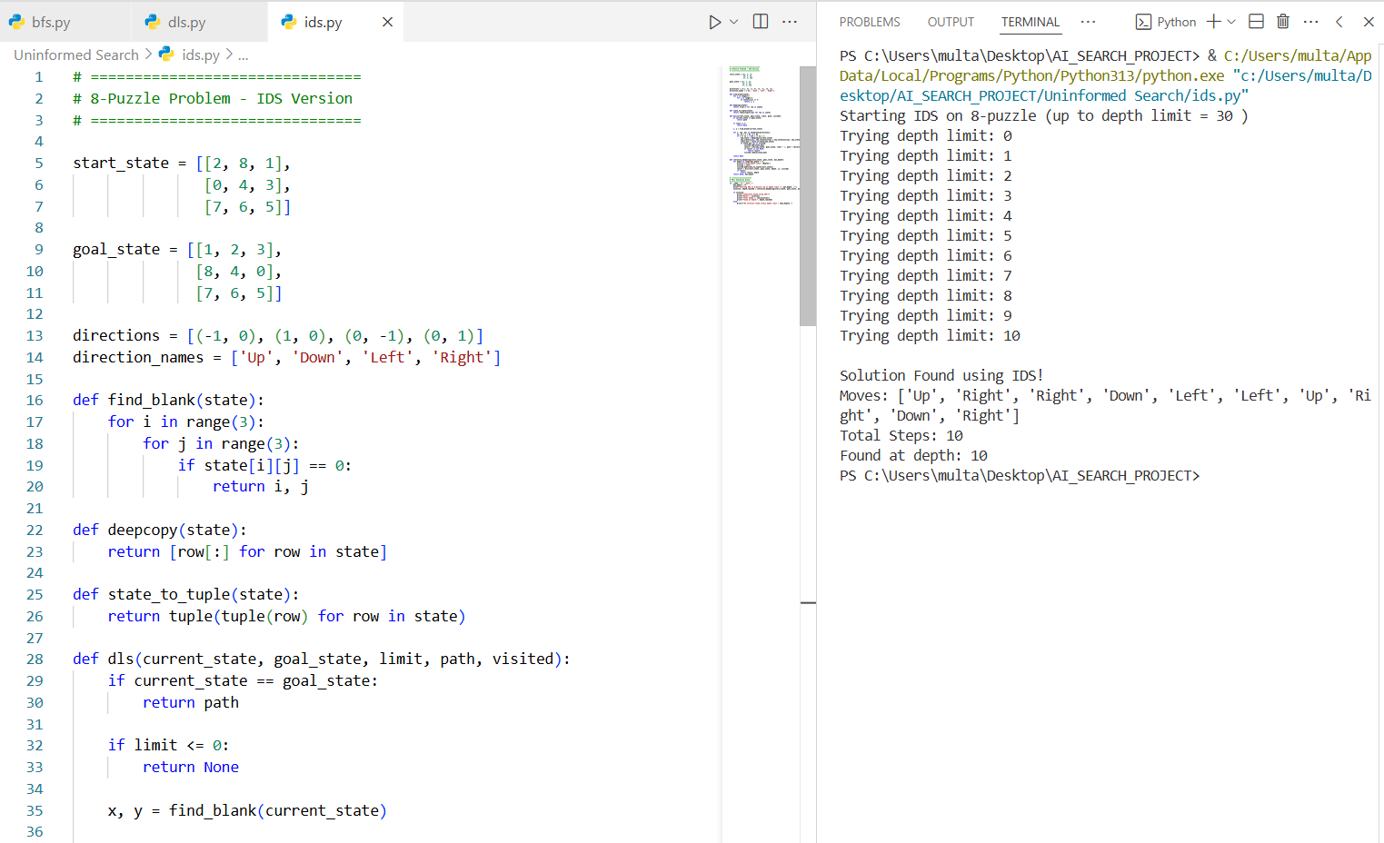

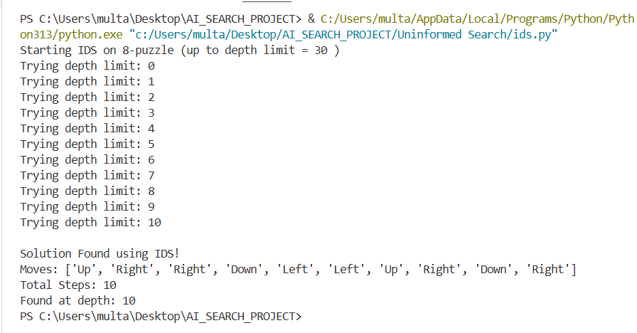

A**s shown in Figure 4, IDS solved the 8-puzzle in 10 moves, combining DFS's space efficiency with BFS’s optimality by incrementally increasing the depth limit.**

##### 5.Uniform Cost Search

Uniform Cost Search is a **pathfinding algorithm** that expands the least cost node first, ensuring that the path to the goal node has the minimum cost. Unlike other search algorithms like Breadth-First Search (BFS), UCS takes into account the cost of each path, making it suitable for weighted graphs where each edge has a different cost.

**Step by step approach:**

* Start from the root node.
* Explore the leftmost child node recursively until you reach a leaf node or a goal state.
* If a goal state is reached, return the solution.
* If a leaf node is reached without finding a solution, backtrack to explore other branches

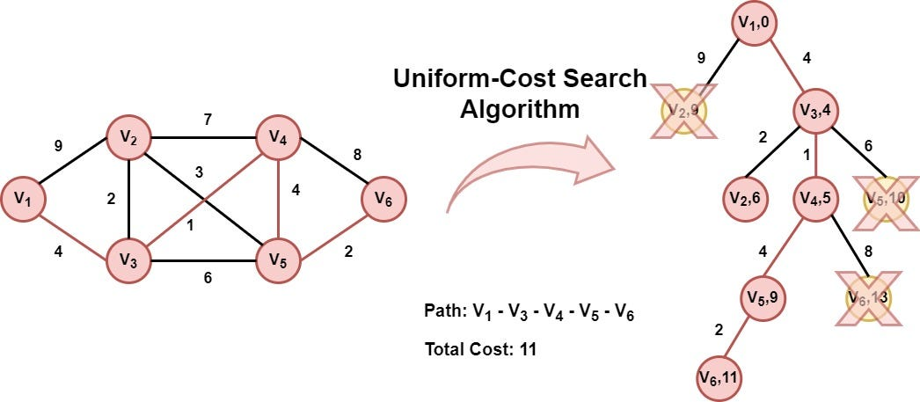

**Complexity**  
d = the depth of the search tree = the number of levels of the search tree.   
ni = number of nodes in level i.   
  
**Time complexity**: Equivalent to the number of nodes traversed in DFS. T(n)=1+n2+n3+...+nd=O(nd)    T(n)=1+n2+n3+...+nd=O(nd)          
**Space complexity:** Equivalent to how large the fringe can get. S(n)=O(n×d)  
**Completeness**: DFS is complete if the search tree is finite, meaning for a given finite search tree, DFS will come up with a solution if it exists.   
**Optimality**: DFS is not optimal, meaning the number of steps in reaching the solution, or the cost spent in reaching it is high.

|  |  |  |
| --- | --- | --- |
|  |  |  |

**Key Concepts of Uniform Cost Search**

1. **Priority Queue:** UCS uses a priority queue to store nodes. The node with the lowest cumulative cost is expanded first. This ensures that the search explores the most promising paths first.
2. **Path Cost:** The cost associated with reaching a particular node from the start node. UCS calculates the cumulative cost from the start node to the current node and prioritizes nodes with lower costs.
3. **Exploration:** UCS explores nodes by expanding the least costly node first, continuing this process until the goal node is reached. The path to the goal node is guaranteed to be the least costly one.
4. **Termination:** The algorithm terminates when the goal node is expanded, ensuring that the first time the goal node is reached, the path is the optimal one.

**Key Characteristics:**

* **Complete**: ✅ Yes
* **Optimal**: ✅ Yes (if cost ≥ 0)
* **Time Complexity**: O(b^d)
* **Space Complexity**: O(b^d)
* **Data Structure**: Priority Queue

**Applications of UCS in AI**

Uniform Cost Search is widely applicable in various fields within AI:

1. **Pathfinding in Maps:** Determining the shortest route between two locations on a map, considering different costs for different paths.
2. **Network Routing:**Finding the least-cost route in a communication or data network.
3. **Puzzle Solving:**Solving puzzles where each move has a cost associated with it, such as the sliding tiles puzzle.
4. **Resource Allocation:** Tasks that involve distributing resources efficiently, where costs are associated with different allocation strategies.

**Advantages of Uniform Cost Search**

* **Optimality:**UCS is guaranteed to find the least cost path to the goal state if the cost of each step exceeds zero.
* **Completeness:**This algorithm is complete; it will find a solution if one exists.

**Challenges with UCS**

* **Space Complexity:**The main drawback of UCS is its space complexity. The priority queue can grow significantly, especially if many nodes are being expanded.
* **Time Complexity:**The time it takes to find the least cost path can be considerable, especially if the state space is large.

**Figure 5: UCS solved puzzle in 10 optimal-cost steps**

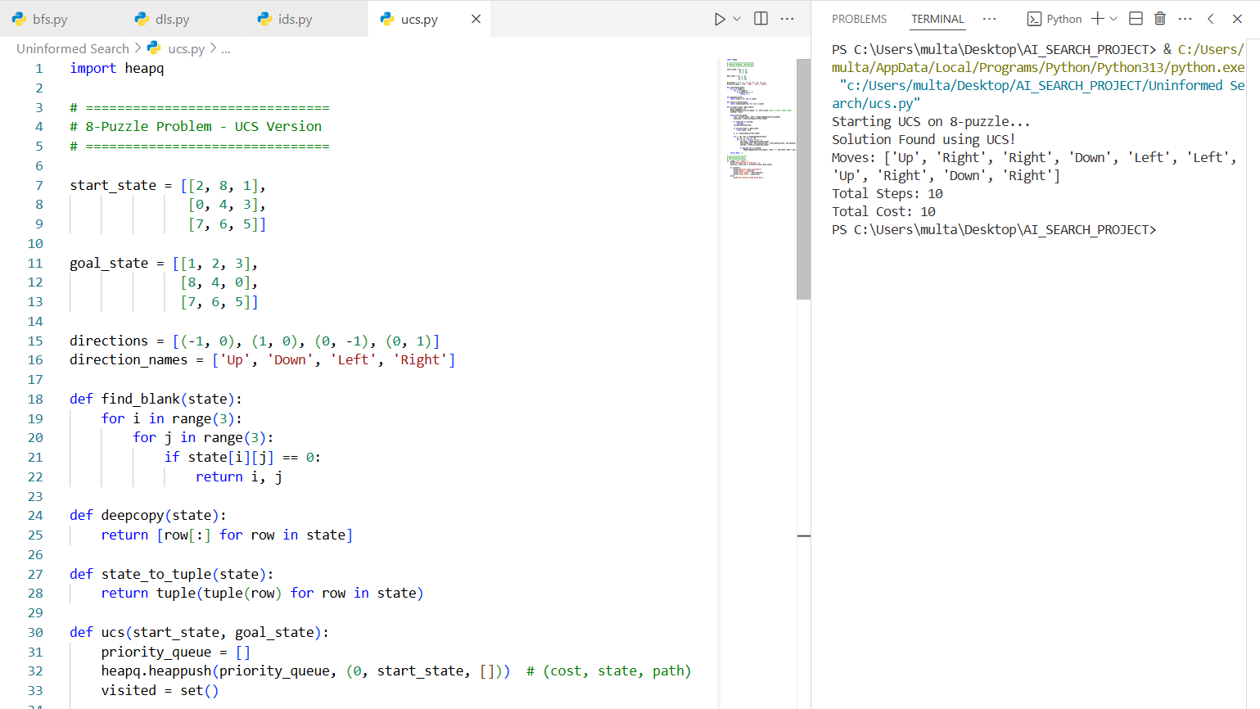

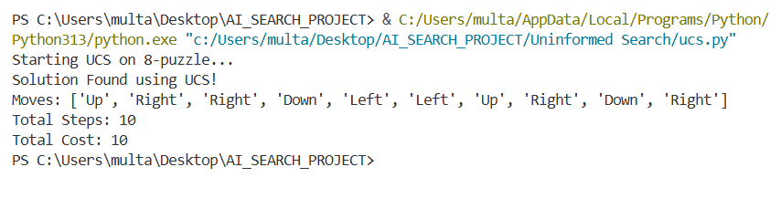

**As shown in Figure 5, UCS found the solution in 10 cost-optimal steps, always expanding the lowest-cost path and ensuring correctness when path costs are equal.**

#### Comparison Table

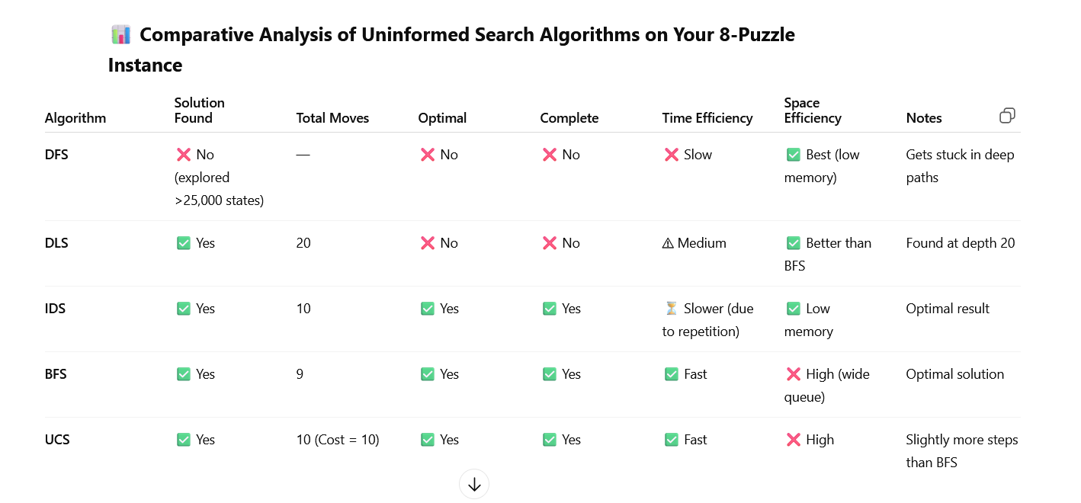

**Performance comparison of uninformed search algorithms applied to the 8-puzzle problem.**

#### Key Takeaways (Specific to Your 8-Puzzle Problem)

1. **DFS** was unable to find a solution even after exploring more than **25,000 states**. This highlights its tendency to get lost in deep, unproductive paths, making it **unreliable for structured puzzles like the 8-puzzle**.
2. **DLS** succeeded only when the depth limit was increased to **20**, but it delivered a **non-optimal path**. It’s slightly more disciplined than DFS but still depends heavily on choosing the correct limit.
3. **IDS** effectively **balances memory efficiency with completeness**. It found an optimal solution in **10 moves**, though it is **slower** than BFS due to repeated searches at each depth.
4. **BFS** outperformed all other methods in terms of **minimal number of moves (9)**. It is **both complete and optimal** but requires **more memory** to store all frontier states.
5. **UCS** produced the same solution length as IDS (**10 moves**) because all moves have equal cost in the 8-puzzle. It’s the best choice **when path cost varies**, but not superior to BFS in this equal-cost setup.



INFORMED SEARCH

An informed search algorithm, also known as a heuristic search, is a type of search algorithm used in artificial intelligence that leverages additional information about the state space of a problem to efficiently find a solution. This additional information, typically in the form of a heuristic function, helps estimate the cost or distance from a given node in the search space to the goal node. The use of heuristics distinguishes informed search algorithms from uninformed search algorithms, which do not use any domain-specific knowledge.

**Key Characteristics of Informed Search Algorithms**

1. **Heuristic Function**: Informed search algorithms use a heuristic function h(n) that provides an estimate of the minimal cost from node n to the goal. This function helps the algorithm to prioritize which nodes to explore first based on their potential to lead to an optimal solution.
2. **Efficiency**: By focusing on more promising paths, informed search algorithms often find solutions more quickly than uninformed methods, especially in large or complex search spaces.
3. **Optimality and Completeness**: Depending on the heuristic used, informed search algorithms can be both optimal and complete. An algorithm is complete if it is guaranteed to find a solution if one exists, and it is optimal if it always finds the best solution. For instance, the A* search algorithm is both complete and optimal when the heuristic function is admissible (i.e., it never overestimates the true cost).

|  |
| --- |
|  |

#### Greedy Best First Search

Greedy Best-First Search is an AI search algorithm that attempts to find the most promising path from a given starting point to a goal. It prioritizes paths that appear to be the most promising, regardless of whether or not they are actually the shortest path. The algorithm works by evaluating the cost of each possible path and then expanding the path with the lowest cost. This process is repeated until the goal is reached.

The algorithm works by using a heuristic function to determine which path is the most promising. The heuristic function takes into account the cost of the current path and the estimated cost of the remaining paths. If the cost of the current path is lower than the estimated cost of the remaining paths, then the current path is chosen. This process is repeated until the goal is reached.

**How Greedy Best-First Search Works?**

* Greedy Best-First Search works by evaluating the cost of each possible path and then expanding the path with the lowest cost. This process is repeated until the goal is reached.
* The algorithm uses a heuristic function to determine which path is the most promising.
* The heuristic function takes into account the cost of the current path and the estimated cost of the remaining paths.
* If the cost of the current path is lower than the estimated cost of the remaining paths, then the current path is chosen. This process is repeated until the goal is reached.

**An example of the best-first search algorithm is below graph, suppose we have to find the path from A to G**

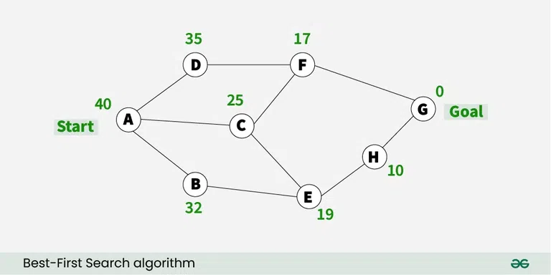

1) We are starting from A , so from A there are direct path to node B( with heuristics value of 32 ) , from A to C ( with heuristics value of 25 ) and from A to D( with heuristics value of 35 ) .

2) So as per best first search algorithm choose the path with lowest heuristics value , currently C has lowest value among above node . So we will go from A to C.

3) Now from C we have direct paths as C to F( with heuristics value of 17 ) and C to E( with heuristics value of 19) , so we will go from C to F.

4) Now from F we have direct path to go to the goal node G ( with heuristics value of 0 ) , so we will go from F to G.

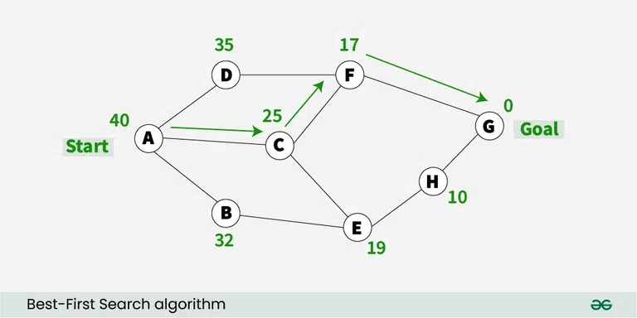

So now the goal node G has been reached and the path we will follow is **A->C->F->G** .

**Applications of Greedy Best-First Search:**

* **Pathfinding:** Greedy Best-First Search is used to find the shortest path between two points in a graph. It is used in many applications such as video games, robotics, and navigation systems.
* **Machine Learning:** Greedy Best-First Search can be used in machine learning algorithms to find the most promising path through a search space.
* **Optimization:** Greedy Best-First Search can be used to optimize the parameters of a system in order to achieve the desired result.
* **Game AI:** Greedy Best-First Search can be used in game AI to evaluate potential moves and chose the best one.
* **Navigation:** Greedy Best-First Search can be use to navigate to find the shortest path between two locations.
* **Natural Language Processing:** Greedy Best-First Search can be use in natural language processing tasks such as language translation or speech recognisation to generate the most likely sequence of words.
* **Image Processing:** Greedy Best-First Search can be use in image processing to segment image into regions of interest.

**Advantages of Greedy Best-First Search:**

* **Simple and Easy to Implement:** Greedy Best-First Search is a relatively straightforward algorithm, making it easy to implement.
* **Fast and Efficient:** Greedy Best-First Search is a very fast algorithm, making it ideal for applications where speed is essential.
* **Low Memory Requirements:** Greedy Best-First Search requires only a small amount of memory, making it suitable for applications with limited memory.
* **Flexible:** Greedy Best-First Search can be adapted to different types of problems and can be easily extended to more complex problems.
* **Efficiency:** If the heuristic function used in Greedy Best-First Search is good to estimate, how close a node is to the solution, this algorithm can be a very efficient and find a solution quickly, even in large search spaces.

**Disadvantages of Greedy Best-First Search:**

* **Inaccurate Results:** Greedy Best-First Search is not always guaranteed to find the optimal solution, as it is only concerned with finding the most promising path.
* **Local Optima:** Greedy Best-First Search can get stuck in local optima, meaning that the path chosen may not be the best possible path.
* **Heuristic Function:** Greedy Best-First Search requires a heuristic function in order to work, which adds complexity to the algorithm**.**
* **Lack of Completeness:** Greedy Best-First Search is not a complete algorithm, meaning it may not always find a solution if one is exists. This can happen if the algorithm gets stuck in a cycle or if the search space is a too much complex.

**Figure 6: Greedy Best-First Search found solution in 9 moves**

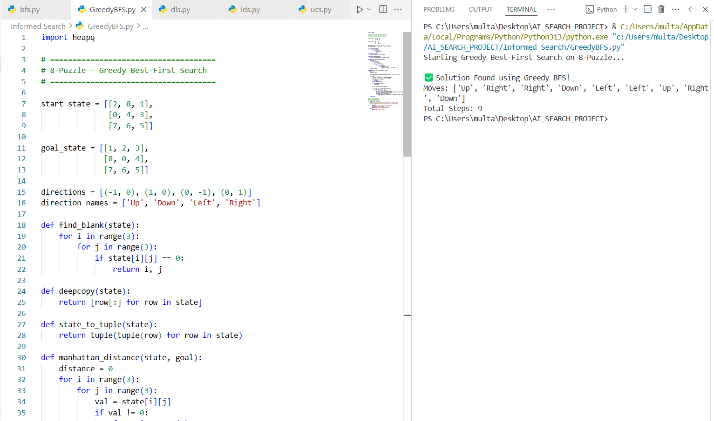

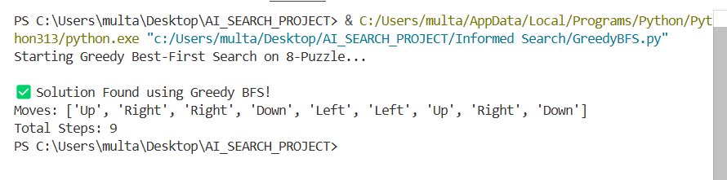

#### As shown in Figure 6, Greedy Best-First Search solved the puzzle in 9 moves by using the Manhattan Distance heuristic, though the solution is not always guaranteed to be optimal.

#### A* SEARCH ALGORITHM

To approximate the shortest path in real-life situations, like- in maps, games where there can be many hindrances.  
We can consider a 2D Grid having several obstacles and we start from a source cell (colored red below) to reach towards a goal cell (colored green below)

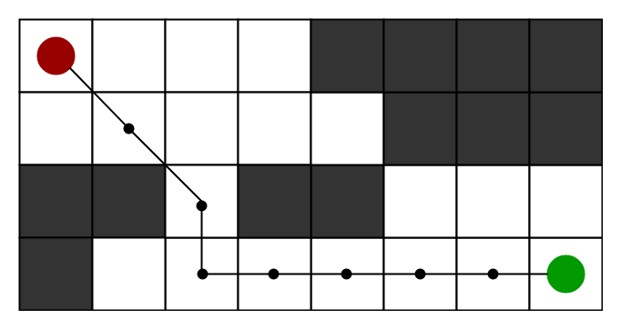

**What is A* Search Algorithm?**   
A* Search algorithm is one of the best and popular technique used in path-finding and graph traversals. The key feature of the A* algorithm is that it keeps a track of each visited node which helps in ignoring the nodes that are already visited, saving a huge amount of time.

**Why A* Search Algorithm?**   
Informally speaking, A* Search algorithms, unlike other traversal techniques, it has “brains”. What it means is that it is really a smart algorithm which separates it from the other conventional algorithms.

The A* algorithm is a heuristic search that combines aspects of both BFS and DFS. It uses a priority queue to explore the most promising states first, guided by an evaluation function f(n)f(n), which is the sum of:

* **g(n)** = Cost from the start node to the current node
* **h(n)** = Estimated cost (heuristic) from the current node to the goal

The total cost function is:

#### f(n)=g(n)+h(n))

The A* algorithm uses heuristics to efficiently explore the state space and find an optimal solution faster than BFS or DFS.

**Key Features of A* Algorithm**

* **Efficient Path Selection**: A* explores paths based on their estimated total cost, ensuring faster goal discovery.
* **Memory of Visited Nodes**: It keeps track of visited nodes, reducing redundant exploration.
* **Optimal Node Expansion**: From a list of generated but unexplored nodes, it selects the most promising one based on the lowest total cost.

**Data Structures Used**

* **Open List**:  
  Holds all generated nodes that are yet to be explored.  
  – Start node is initially added here.
* **Closed List**:  
  Contains nodes that have been fully explored (i.e., all neighbors have been examined).
* **Parent Pointers**:  
  Every node maintains a pointer to its parent to **retrace the final path** once the goal is reached.

**Heuristics in 8-Puzzle Problem**

Two popular heuristics used to estimate the h-score are:

1. **Misplaced Tiles**:  
   Count of tiles not in their goal position.
2. **Manhattan Distance**:  
   Sum of distances (row + column) of tiles from their correct positions.

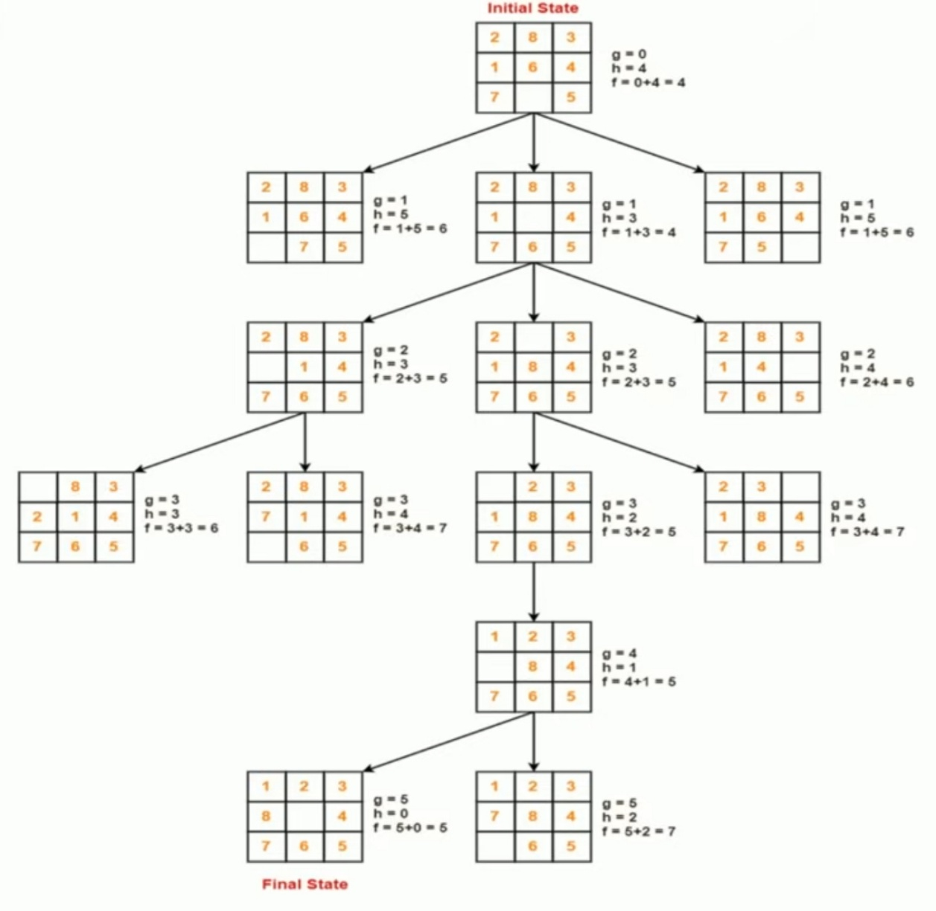

#### How A* solves the 8-Puzzle problem.

We first move the empty space in all the possible directions in the start state and calculate the **f-score** for each state. This is called expanding the current state.  
After expanding the current state, it is pushed into the **closed** list and the newly generated states are pushed into the **open** list. A state with the least f-score is selected and expanded again. This process continues until the goal state occurs as the current state. Basically, here we are providing the algorithm a measure to choose its actions. The algorithm chooses the best possible action and proceeds in that path.   
This solves the issue of generating redundant child states, as the algorithm will expand the node with the least **f-score**.

#### A** Algorithm Implementation**

The algorithm maintains a priority queue (min-heap) of nodes to explore, ranked by f(n). Key components include:

* Node Structure: Tracks state, parent, depth, and path cost.
* Manhattan Distance: Sum of distances each tile is from its goal position.
* Visited Set: Avoids re-exploring repeated states.

**Pseudocode Overview:**

**def** a_star(start, goal):  
 frontier = PriorityQueue()  
 explored = set()  
 frontier.put(start, priority=f(start))  
  
 **while** **not** frontier.empty():  
 node = frontier.get()  
 **if** node == goal:  
 **return** reconstruct_path(node)  
  
 explored.add(node)  
 **for** neighbor **in** get_neighbors(node):  
 **if** neighbor **not** **in** explored:  
 cost = g(neighbor) + h(neighbor)  
 frontier.put(neighbor, priority=cost)

#### Heuristic Function

We use Manhattan distance:

h(n) = ∑ (|x_i - x'_i| + |y_i - y'_i|)

This heuristic is admissible (never overestimates) and consistent, ensuring A* returns an optimal solution..

**Figure 7: A* Search solved puzzle in 9 optimal moves**

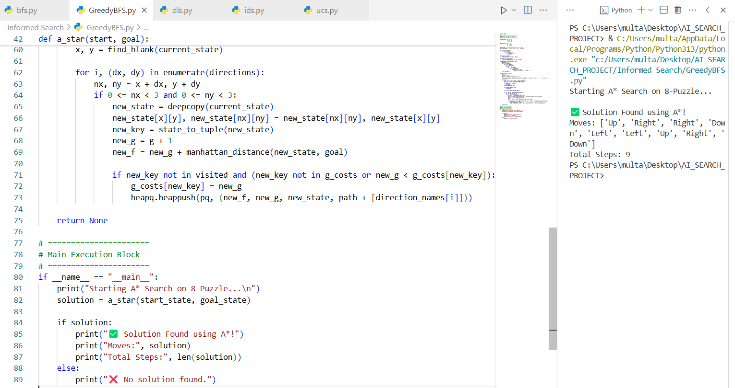

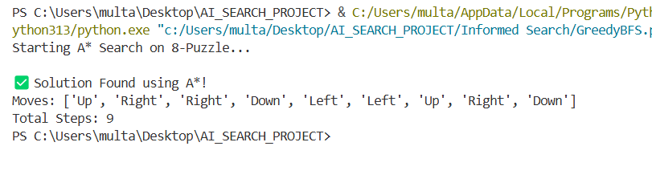

**As shown in Figure 7, A* Search solved the 8-puzzle in 9 optimal moves, using both the actual cost and heuristic estimate to efficiently find the best path.**

**Advantages of A* Algorithm**

1. **Optimality**  
   A* always finds the least-cost (optimal) path if the heuristic used is admissible (never overestimates).
2. **Completeness**  
   A* is guaranteed to find a solution if one exists, as long as the search space is finite.
3. **Heuristic-Guided**  
   Combines the power of Dijkstra’s algorithm and Greedy Best-First Search by using both actual cost and estimated cost.
4. **Customizable Heuristics**  
   Allows use of different heuristics like:
   * Manhattan Distance (commonly used in 8-puzzle)
   * Number of misplaced tiles
5. **Path Reconstruction**  
   Tracks the parent of each node, allowing the solution path to be easily reconstructed.

**Limitations**Although being the best path finding algorithm around, A* Search Algorithm doesn’t produce the shortest path always, as it relies heavily on heuristics / approximations to calculate – h

**Disadvantages of A* Algorithm**

1. **High Memory Usage**  
   Stores all generated nodes in memory, which can grow rapidly for large problems (like sliding puzzles or maps).
2. **Time-Consuming for Large Search Spaces**  
   Although guided, it may still explore many nodes, especially with poor heuristics.
3. **Performance Depends on Heuristic**  
   If the heuristic is not well designed, performance degrades significantly.
4. **Not Ideal for Real-Time Systems**  
   Due to its memory and time requirements, A* may not be suitable for systems requiring fast, reactive decisions.

**Summary Table**

|  |  |
| --- | --- |
| Property | A* Search (8-Puzzle Context) |
| Complete | ✅ Yes (if branching factor is finite) |
| Optimal | ✅ Yes (with admissible heuristic) |
| Heuristic Used | Manhattan Distance / Misplaced Tiles |
| Time Complexity | O(b^d) |
| Space Complexity | O(b^d) |
| Best Use Case | Shortest path finding where memory is sufficient |
| Worst Case | Slow with large memory usage if heuristic is bad |

#### Compare All Informed Search Algorithms (Internally)

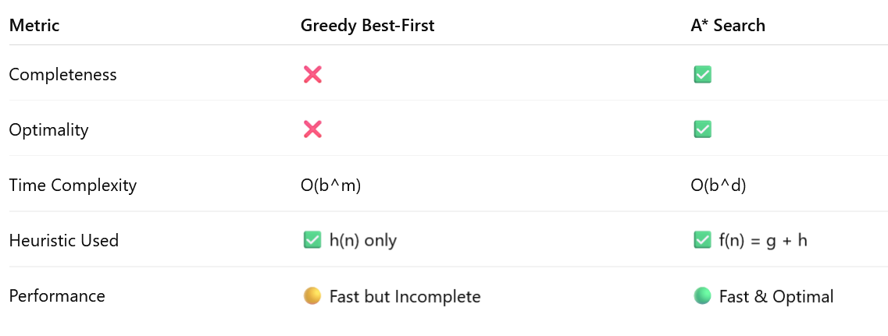

# COMPARISON BETWEEN

# UNINFORMED VS INFORMED SEARCH

|  |  |  |
| --- | --- | --- |
| **Feature** | **Uninformed Search** | **Informed Search** |
| **Definition** | No domain-specific knowledge is used | Uses heuristics to guide the search |
| **Exploration Strategy** | Blindly explores all paths (breadth/depth/cost-based) | Prioritizes paths likely to lead to the goal sooner |
| **Heuristic Function (h(n))** | ❌ Not used | ✅ Required (e.g., misplaced tiles, Manhattan distance) |
| **Examples** | BFS, DFS, UCS, IDS | Greedy Best-First Search, A* |
| **Completeness** | Varies (e.g., DFS ❌, BFS ✅) | Generally ✅ (e.g., A*) |
| **Optimality** | UCS, BFS = ✅; others = ❌ | A* = ✅, Greedy = ❌ |
| **Time Complexity** | High – often O(b^d) | Lower – focuses on promising paths |
| **Space Complexity** | High – stores all explored nodes | Still high (A* stores open/closed lists) |
| **Best Case Efficiency** | May explore thousands of nodes | Can solve in fewer node expansions |

#### Visual Example – Node Expansion (Simplified)

**BFS Node Tree (Uninformed)**

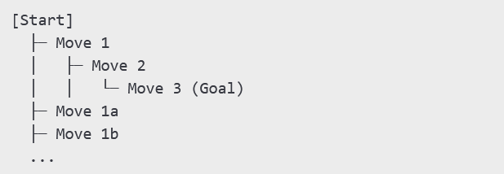

***A Node Expansion Tree (Informed Search)***

🔴 **Expands wide**, explores many irrelevant nodes.

**A* Node Tree (Informed)**

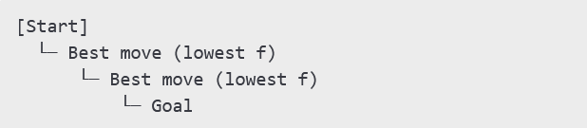

***Node expansion using A* shows more targeted path selection.**

🟢 **Explores only best path candidates**, guided by f(n) = g(n) + h(n).

Here is a visual infographic (bar graph) showing the **number of moves required by each search algorithm** to solve your 8-puzzle instance:

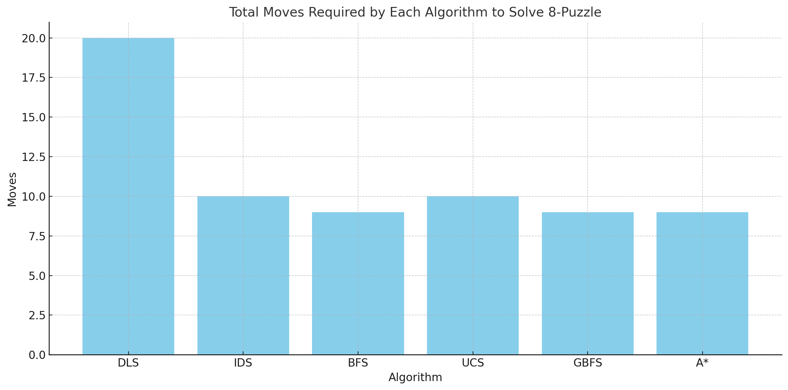

#### Final Comparative Analysis of Search Algorithms on

#### the 8-Puzzle Problem

|  |  |  |  |  |  |  |  |  |
| --- | --- | --- | --- | --- | --- | --- | --- | --- |
| **Algorithm** | **Solution Found** | **Total Moves** | **Optimal** | **Complete** | **Time Efficiency** | **Space Efficiency** | **Heuristic Used** | **Notes** |
| **DFS** | ❌ No (failed after 25,000 states) | – | ❌ No | ❌ No | ❌ Very slow | ✅ Very low (stack-based) | None | Gets lost in deep paths |
| **DLS** | ✅ Yes | 20 | ❌ No | ❌ No | ⚠ Medium | ✅ Low | None | Found at depth limit 20 |
| **IDS** | ✅ Yes | 10 | ✅ Yes | ✅ Yes | ⏳ Slower (repeated work) | ✅ Very low | None | Complete & memory-efficient |
| **BFS** | ✅ Yes | 9 | ✅ Yes | ✅ Yes | ✅ Fast | ❌ High | None | Guaranteed shortest path |
| **UCS** | ✅ Yes | 10 (Cost = 10) | ✅ Yes | ✅ Yes | ✅ Fast | ❌ High | Path cost only (g) | Same as BFS here due to equal cost |
| **GBFS** | ✅ Yes | 9 | ⚠ Sometimes | ❌ No | ✅ Very fast | ✅ Moderate | Manhattan Distance (h) | Fast but not always optimal |
| **A\*** | ✅ Yes | 9 | ✅ Yes | ✅ Yes | ✅ Efficient | ⚠ Medium to high | g + h (Manhattan) | Best balance of speed and accuracy |

**Interpretation:**

* **BFS**, **GBFS**, and **A\*** all solved the puzzle in the **minimum 9 moves**.
* **IDS** and **UCS** took 10 moves.
* **DLS** found a non-optimal path requiring 20 moves.
* **DFS** is not shown since it failed to find a solution.

**Conclusion: Why A* is Best for Solving 8-Puzzle**

*A*\* is the best algorithm overall** for the 8-puzzle due to:

* + ✅ **Optimality**: Always finds the shortest solution path
  + ✅ **Heuristic guidance**: Prioritizes promising states, reducing search time
  + ✅ **Balance**: Combines cost so far (**g(n)**) and estimated cost (**h(n)**)
  + ✅ **Efficiency**: Solves puzzles in fewer steps than BFS, DFS, or UCS
  + ✅ **Scalability**: Works well even on harder puzzles (e.g., 15-puzzle)

**References**

1. Russell, S. J., & Norvig, P. (2020). *Artificial Intelligence: A Modern Approach* (4th ed.). Pearson.
2. Korf, R. E. (1985). Depth-first iterative-deepening: An optimal admissible tree search. *Artificial Intelligence*, 27(1), 97–109.
3. Hart, P. E., Nilsson, N. J., & Raphael, B. (1968). A Formal Basis for the Heuristic Determination of Minimum Cost Paths. *IEEE Transactions on Systems Science and Cybernetics*, 4(2), 100–107.
4. https://www.geeksforgeeks.org/a-search-algorithm/
5. [https://en.wikipedia.org/wiki/A*_search_algorithm](https://en.wikipedia.org/wiki/A*_search_algorithm)